**Week 2: BASIC JUNIT TESTING EXERCISES**

**Exercise 1: Setting Up Junit**

**Scenario:** You need to set up JUnit in your Java project to start writing unit tests.

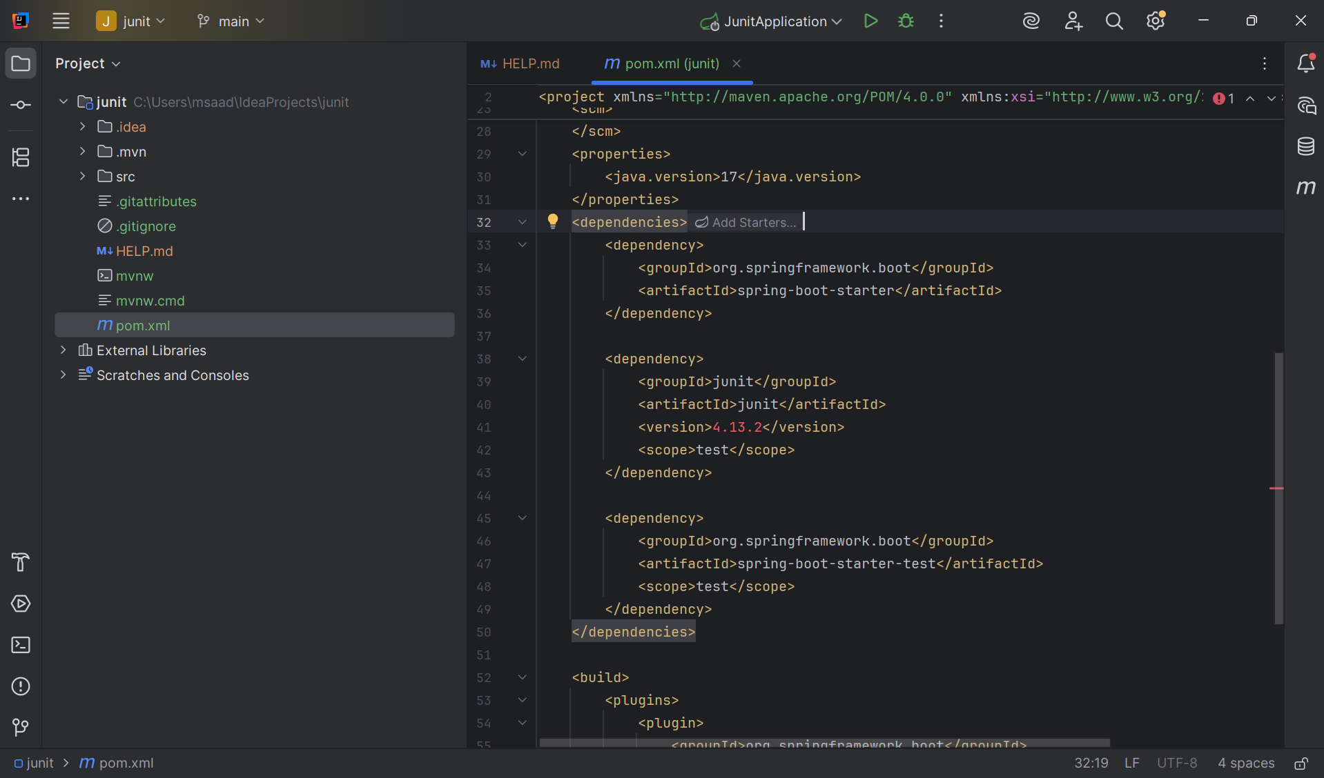

**Exercise 3: Assertions in JUnit**

**Scenario:** You need to use different assertions in JUnit to validate your test results.

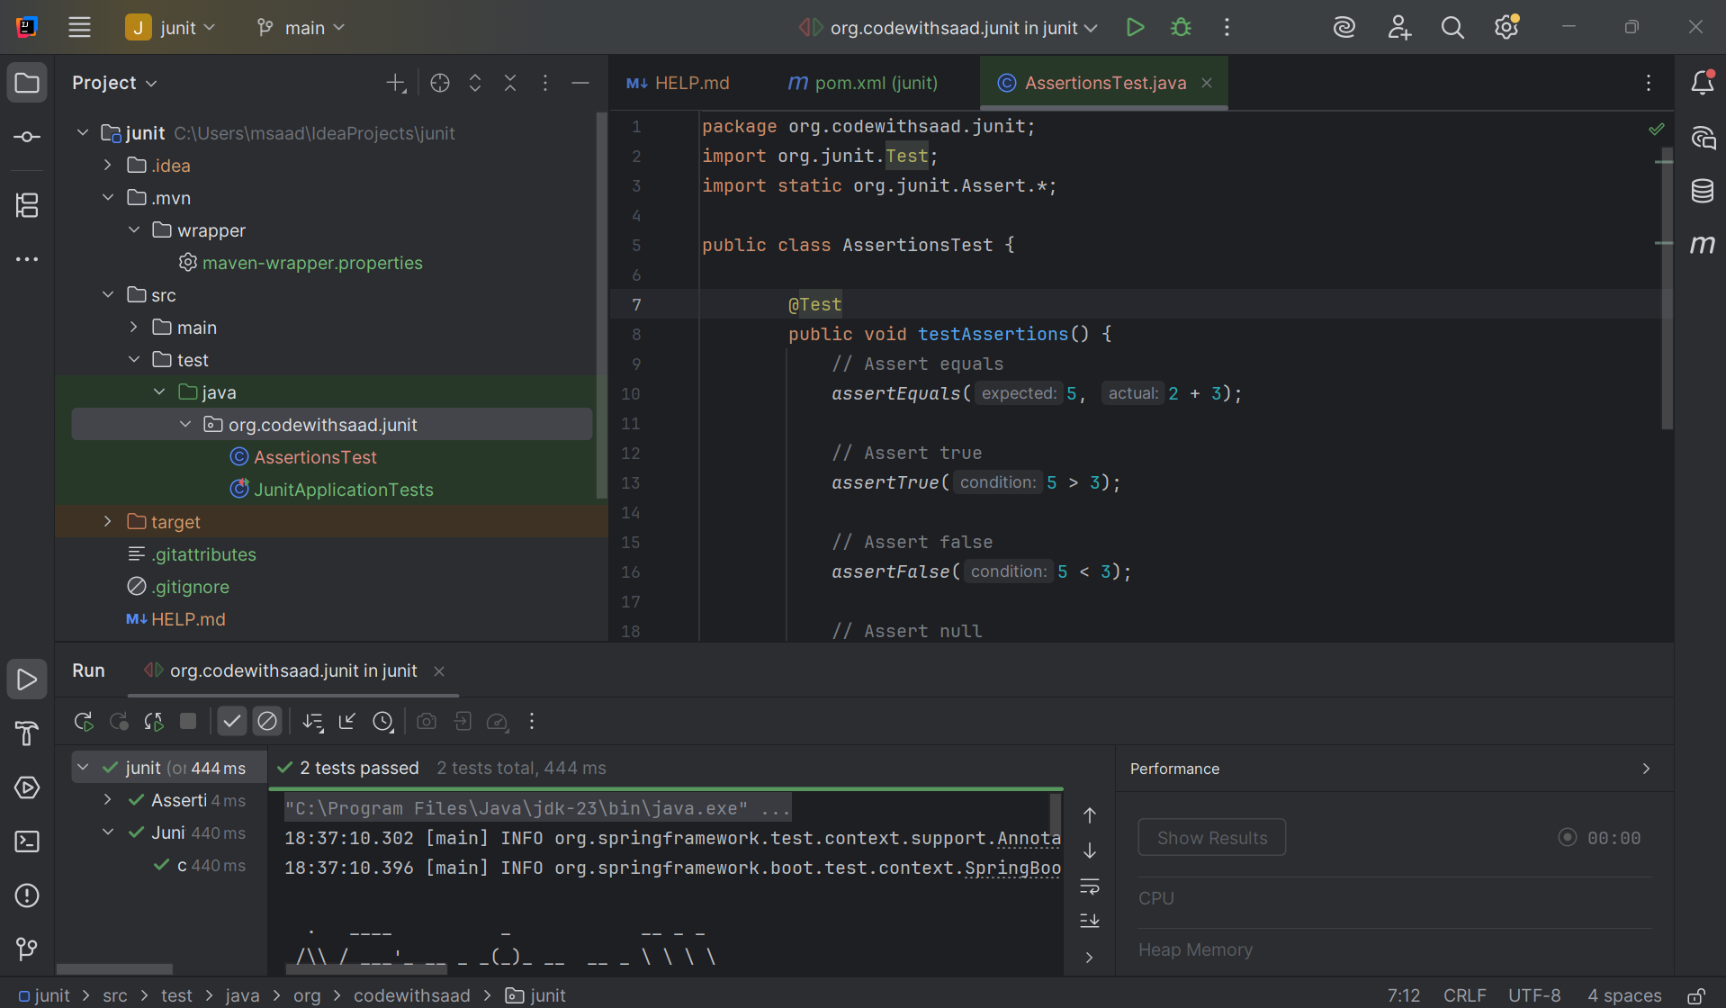

**Exercise 4: Arrange-Act-Assert (AAA) Pattern, Test Fixtures, Setup and Teardown Methods in JUnit**

**Scenario:** You need to organize your tests using the Arrange-Act-Assert (AAA) pattern and use setup and teardown methods.

**Calculator.java**

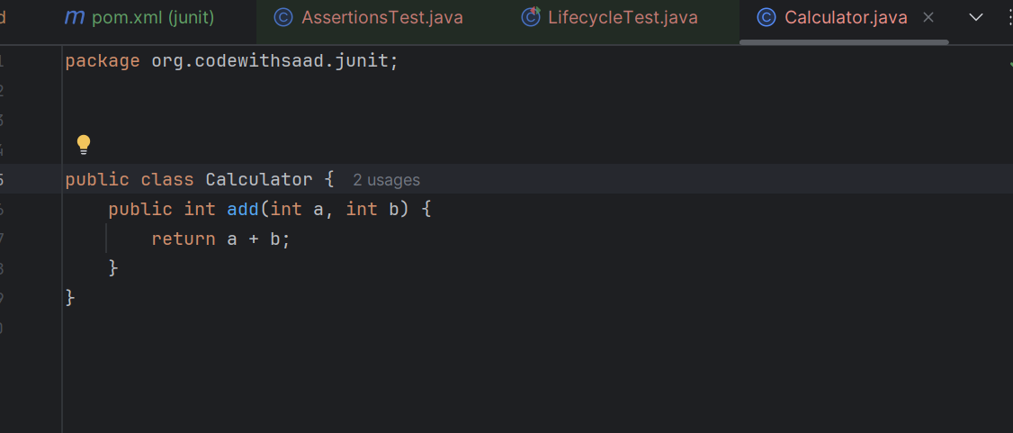

**LifecycleTest.java**

package org.codewithsaad.junit;  
  
import org.junit.After;  
import org.junit.Before;  
import org.junit.Test;  
import static org.junit.Assert.*;  
  
public class LifecycleTest {  
 private Calculator calc;  
  
 @Before  
 public void setUp() {  
 calc = new Calculator();  
 System.*out*.println("Setup completed.");  
 }  
  
 @Test  
 public void testAdd() {  
 // Arrange done in setup  
 // Act  
 int result = calc.add(2, 3);  
 // Assert  
 *assertEquals*(5, result);  
 }  
  
 @After  
 public void tearDown() {  
 System.*out*.println("Teardown completed.");  
 }  
}

**Output:**

